How to setup Kubernetes on your local machine?

minikube is local Kubernetes, focusing on making it easy to learn and develop for Kubernetes.

All you need is Docker (or similarly compatible) container or a Virtual Machine environment,

What you’ll need

* 2 CPUs or more
* 2GB of free memory
* 20GB of free disk space
* Internet connection
* Container or virtual machine manager, such as: [Docker](https://minikube.sigs.k8s.io/docs/drivers/docker/), [QEMU](https://minikube.sigs.k8s.io/docs/drivers/qemu/), [Hyperkit](https://minikube.sigs.k8s.io/docs/drivers/hyperkit/), [Hyper-V](https://minikube.sigs.k8s.io/docs/drivers/hyperv/), [KVM](https://minikube.sigs.k8s.io/docs/drivers/kvm2/), [Parallels](https://minikube.sigs.k8s.io/docs/drivers/parallels/), [Podman](https://minikube.sigs.k8s.io/docs/drivers/podman/), [VirtualBox](https://minikube.sigs.k8s.io/docs/drivers/virtualbox/), or [VMware Fusion/Workstation](https://minikube.sigs.k8s.io/docs/drivers/vmware/)

**Here are the instructions for Docker as a container manager on Windows 11.**

* 1. Docker desktop need “Hyper-V” option to be enabled on your machine. Please enable to if it is already not enabled. And restart the system before you proceed with the next step.
     + **Search for “Turn Windows feature on or off” in windows search**

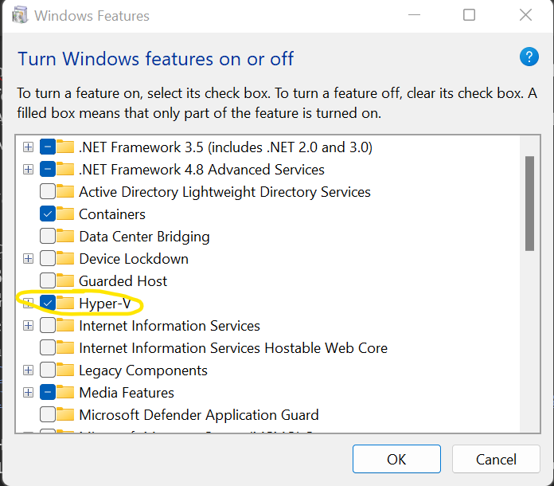

* + - Select the check-box to enable
    - Restart your machine.
  1. Install Docker desktop to setup docker as container manager on your local machine
  2. If you have admin rights to install software, then you can directly download docker desktop from below link

<https://www.docker.com/products/docker-desktop/>

* 1. To do it without admin rights, download Visual Studio Code (VS code) in .zip format
  2. Unzip and start VS code application

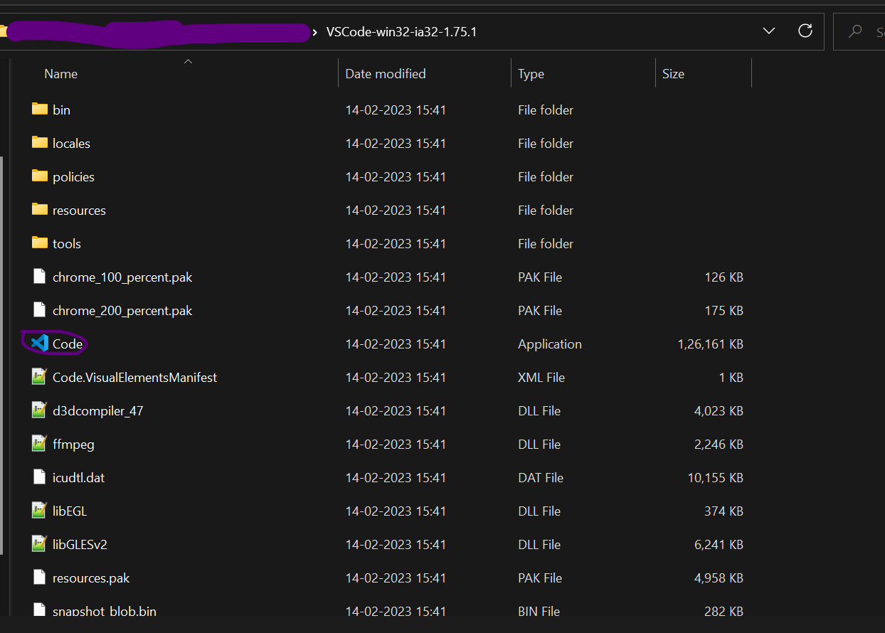

* 1. In VS code, go to extensions and search for “Docker” then click on install

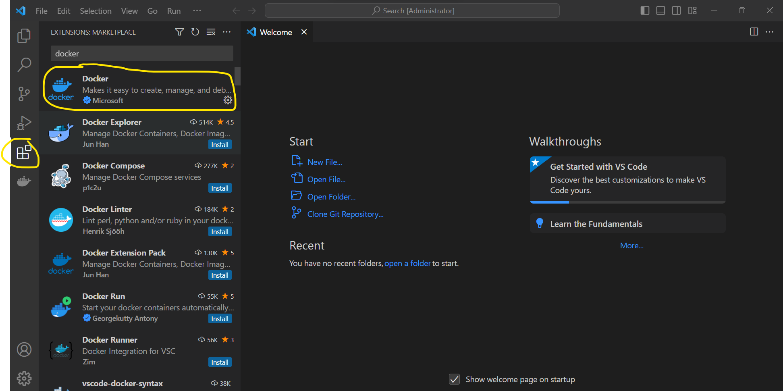

* 1. When the installation starts you will get a wizard to install docker. Uncheck “Use WSL 2 instead of Hyper-V” option.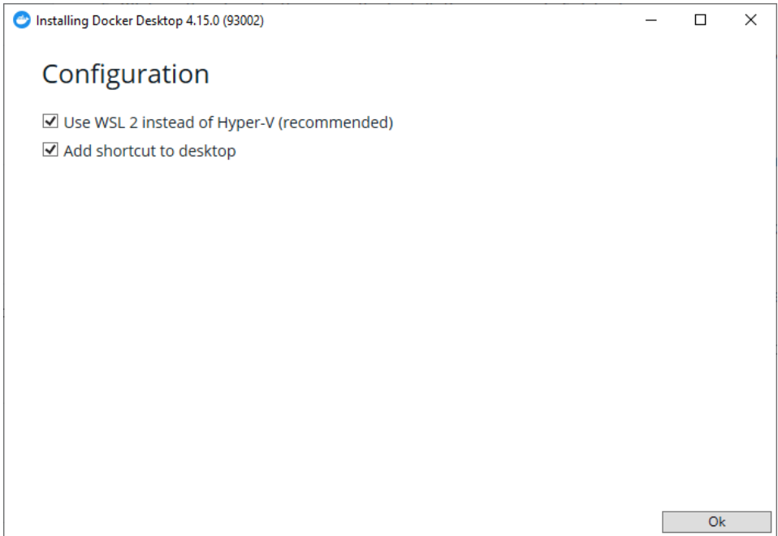
  2. It will take time to install Docker desktop.
  3. Once installed, docker desktop should be up and running if everything goes fine.
  4. Below error also might occur which prevents Docker desktop to start.

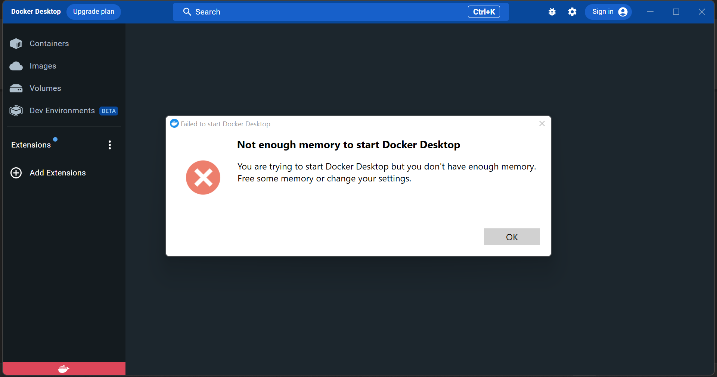

* 1. Click on the troubleshoot option and click “Reset to factory defaults”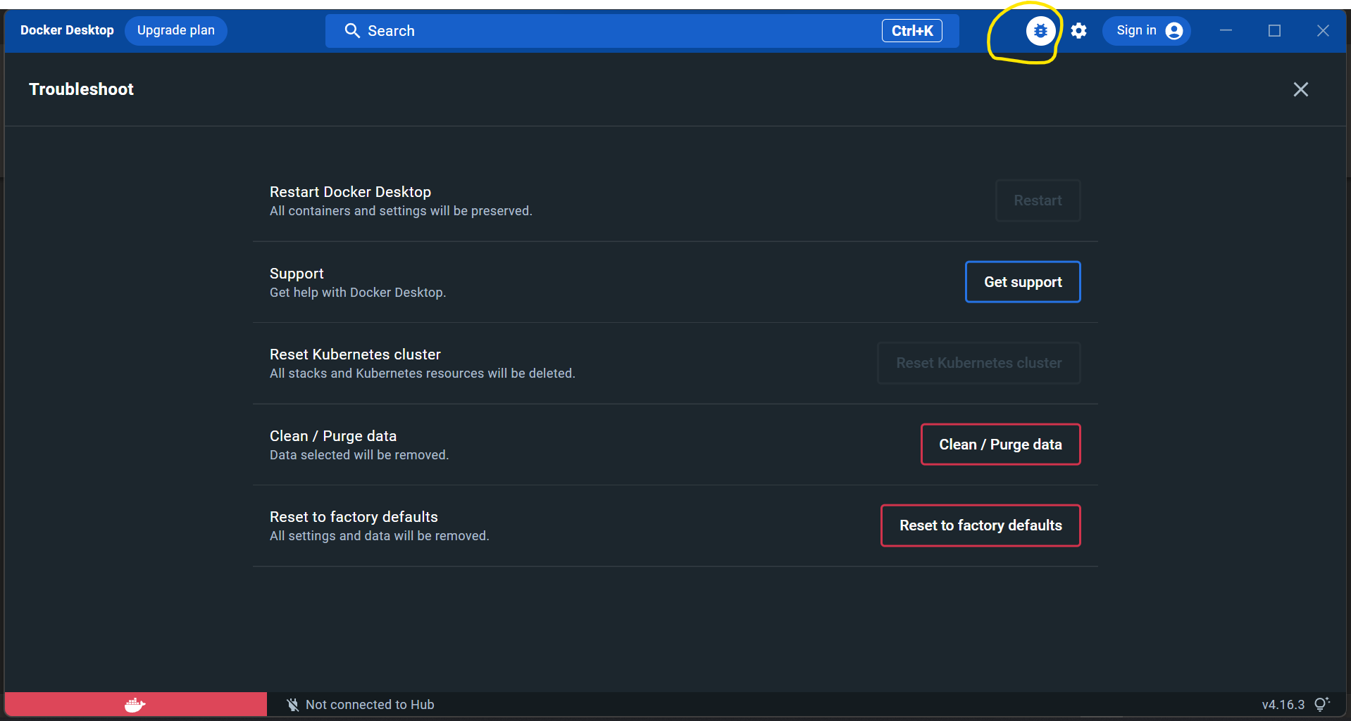

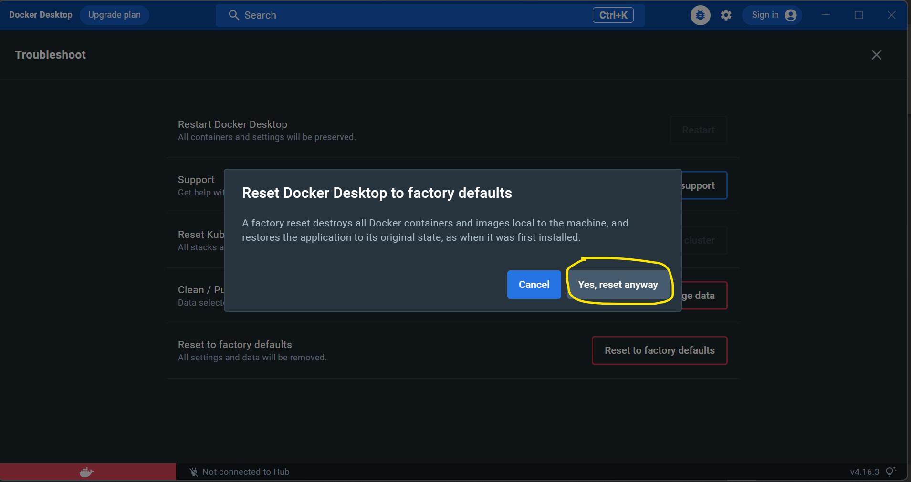

* 1. **If this does not help then please restart the system and try with the below configuration**

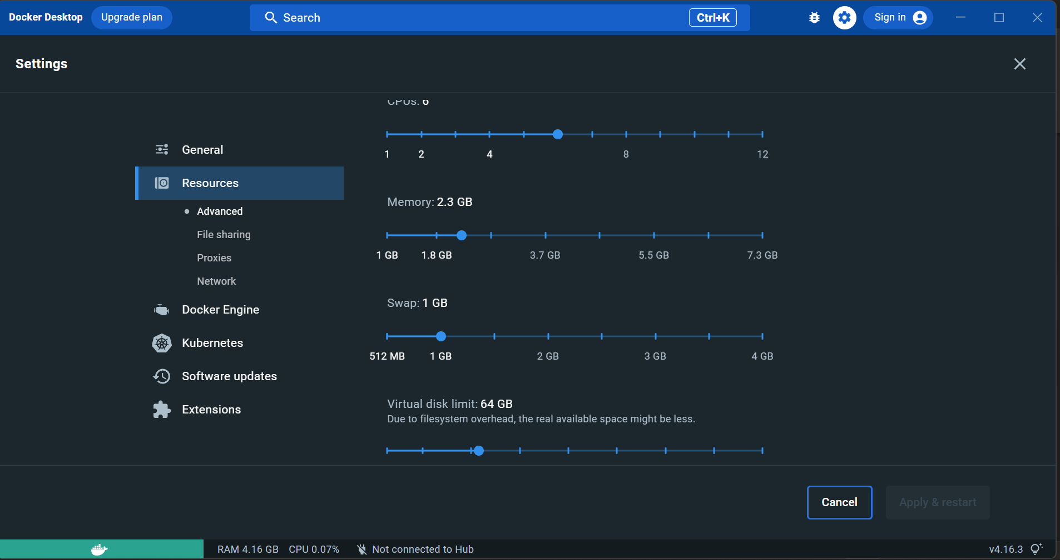

* 1. Once docker is up and running then we need to setup minikube
  2. If you directly download the minikube installer then it needs to be installed with admin rights. To use the minikube directly without any admin rights , download from below link.

[**https://github.com/kubernetes/minikube/releases**](https://github.com/kubernetes/minikube/releases)

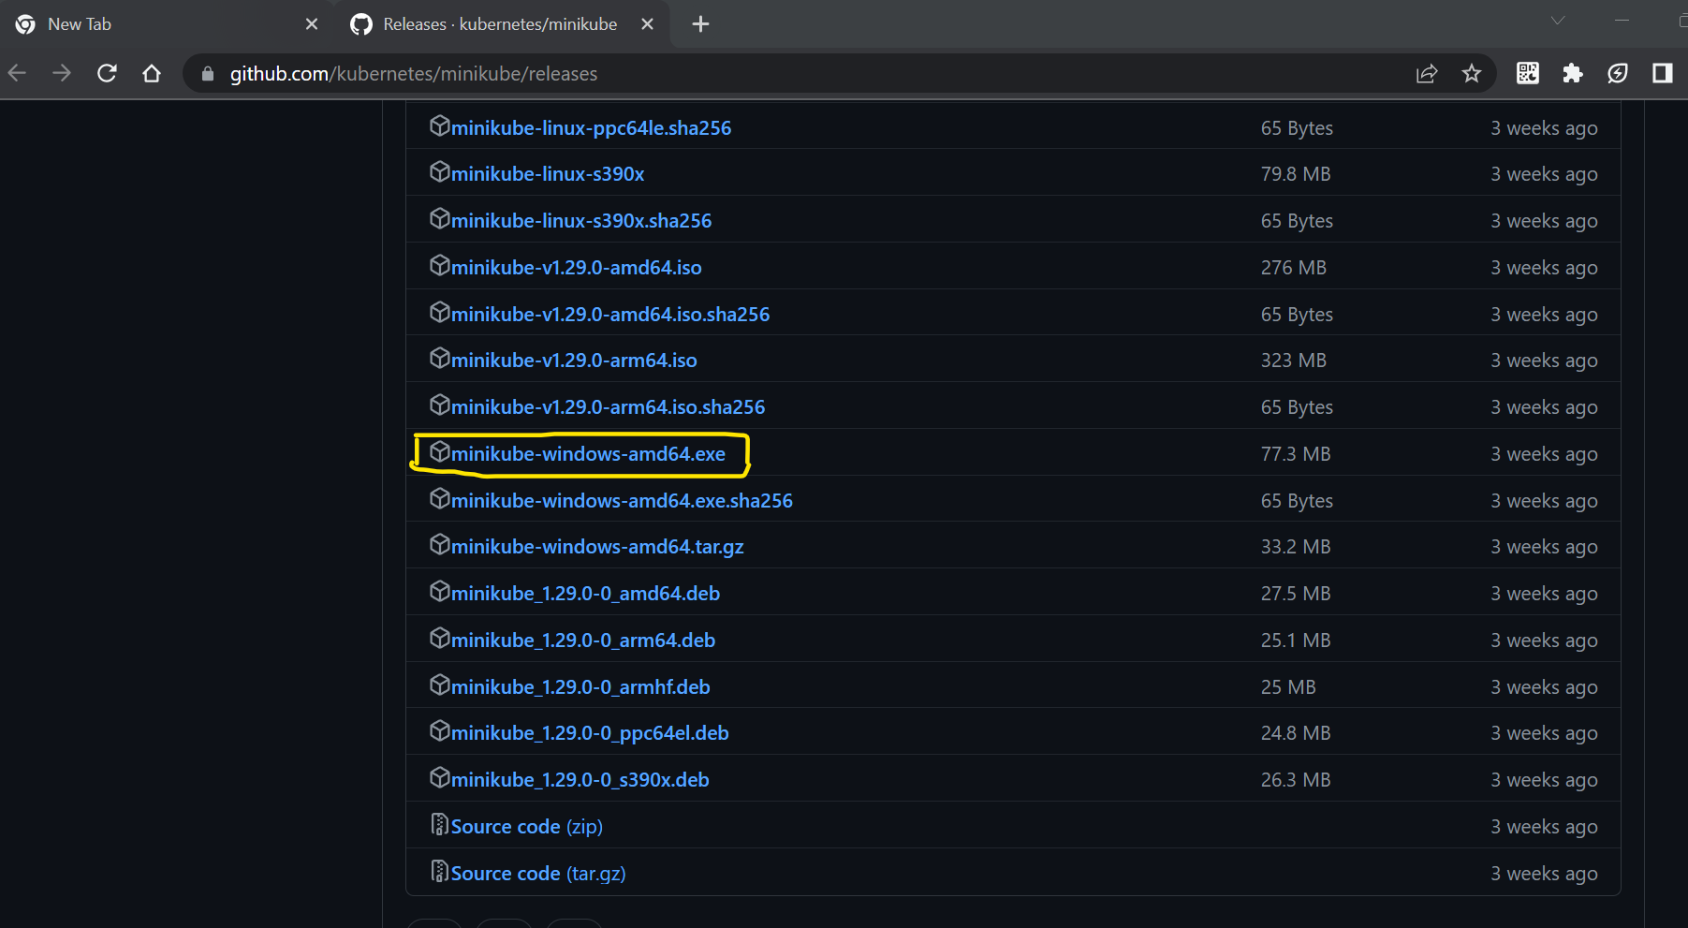

* 1. Rename the downloaded file to minikube and place it a separate folder.
  2. Next download **kubectl**

The Kubernetes command-line tool, [kubectl](https://kubernetes.io/docs/reference/kubectl/kubectl/), allows you to run commands against Kubernetes clusters. You can use kubectl to deploy applications, inspect and manage cluster resources, and view logs

[**https://kubernetes.io/docs/tasks/tools/install-kubectl-windows/**](https://kubernetes.io/docs/tasks/tools/install-kubectl-windows/)

* 1. Keep kubectl file also in the same folder as minikube
  2. Set this folder in Path Environment variable

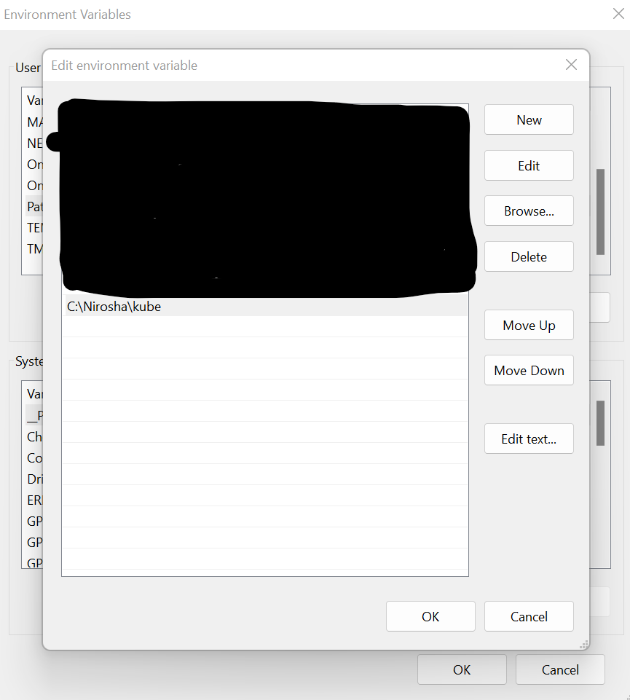

* 1. Open Powershell or command prompt and check whether minikube and kubectl are correctly set on Path

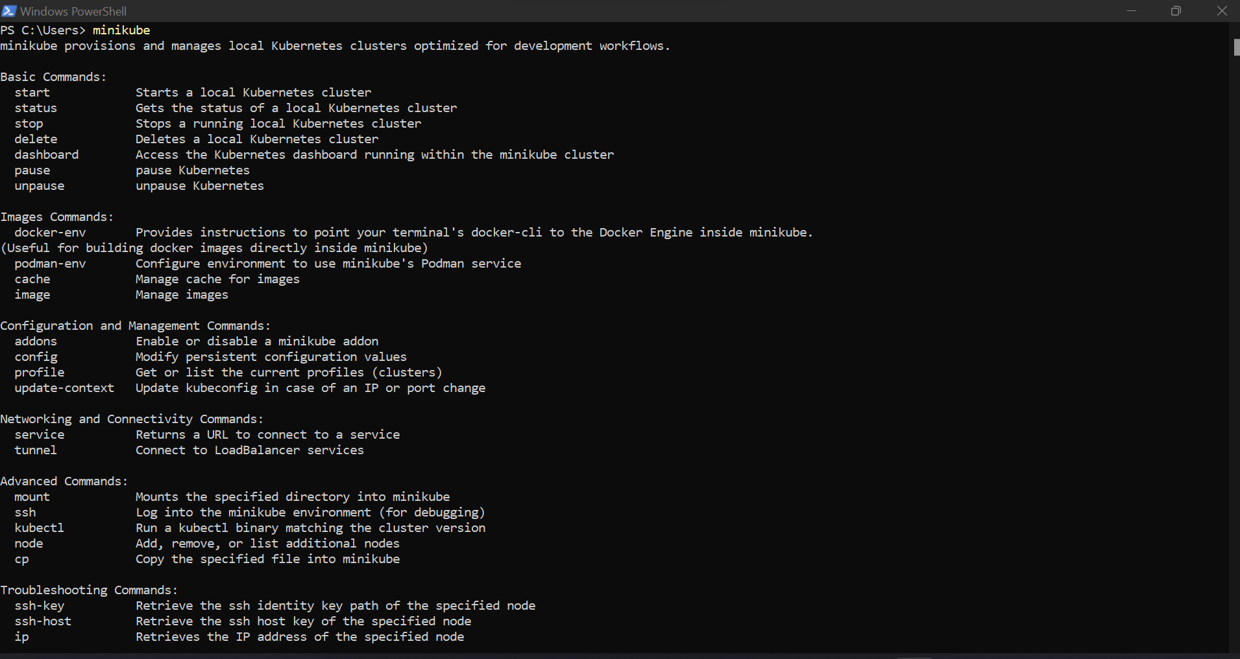

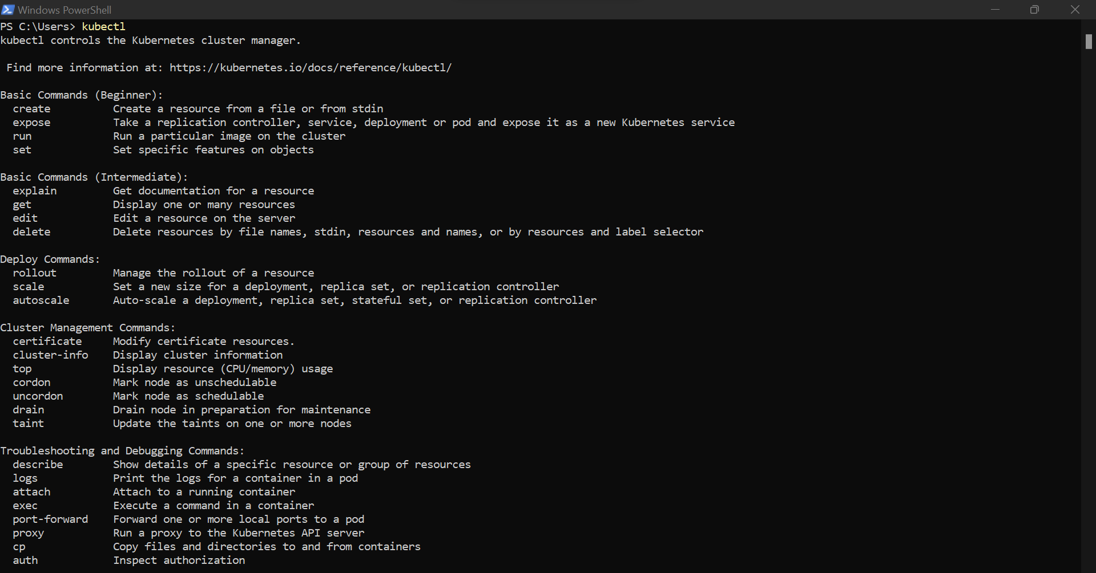

* 1. Start the minikube (docker desktop should be in running state to start minikube)

**Command : minikube start –driver=docker**

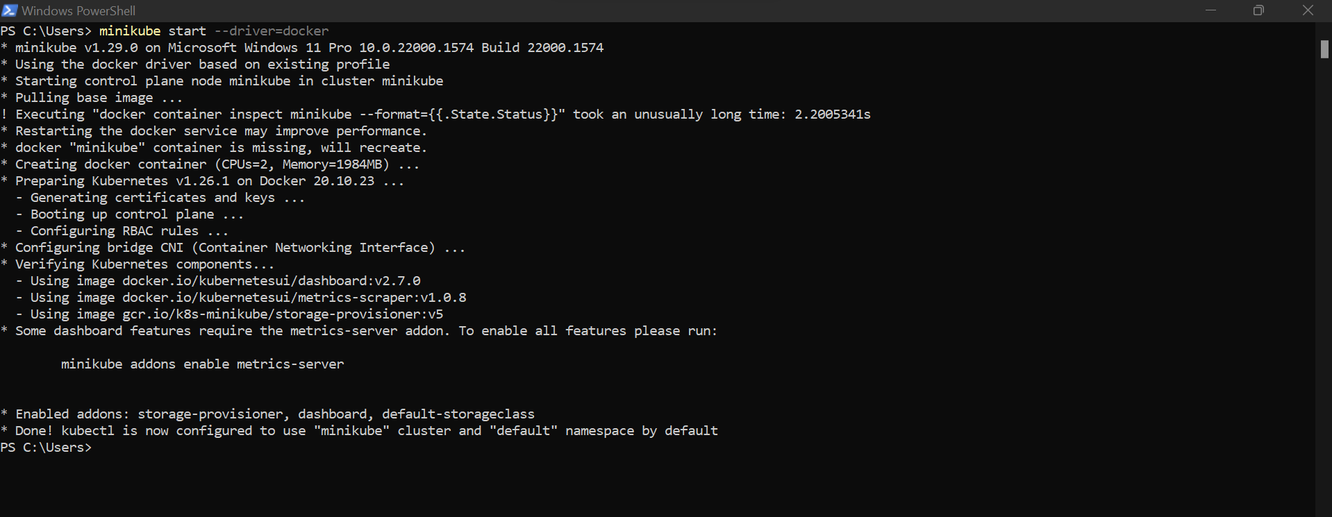

* 1. If the minikube started successfully then the below command should give the status as shown in screenshot

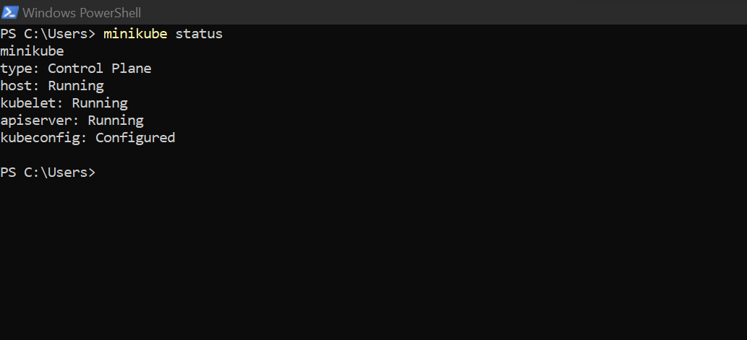

**Deploy simple springboot application on minikube:**



1. Push image to docker
2. Deploy on minikube
3. **Push image to docker**

* Build the springboot application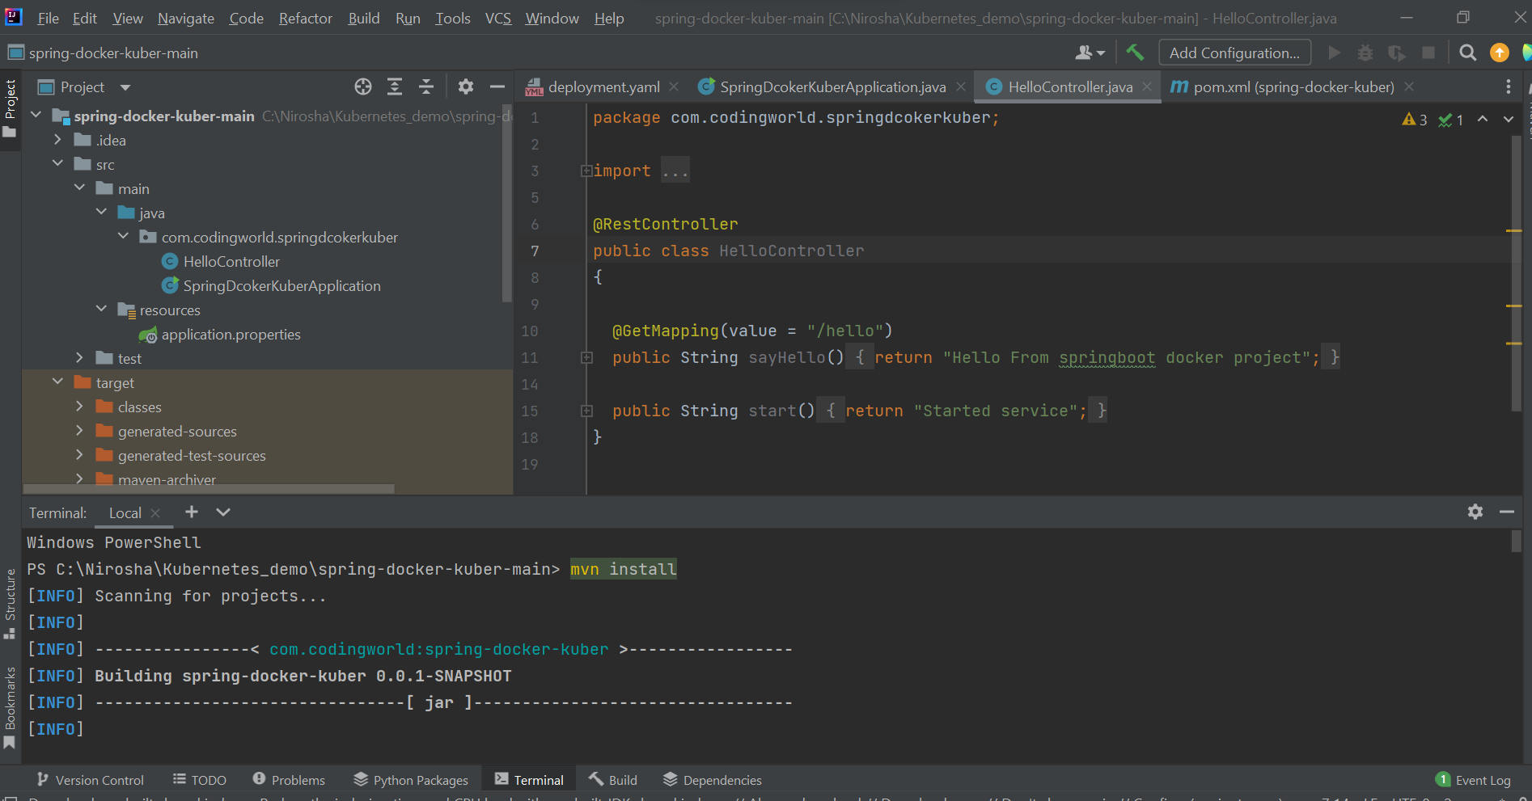
  + once its successful then use the below command to create image

docker build -t spring-docker-kuber .

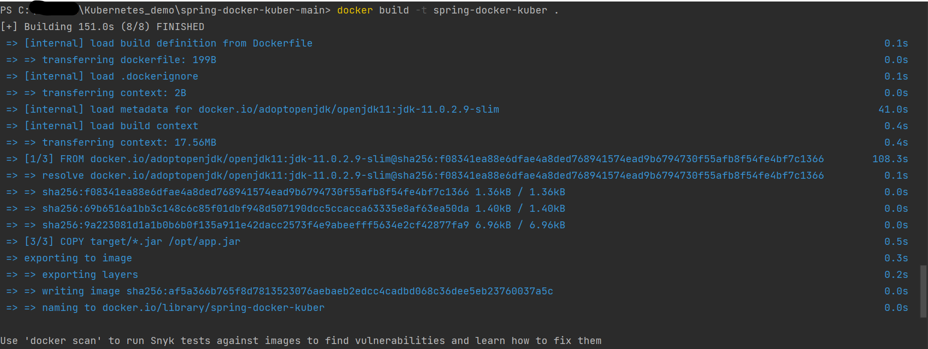

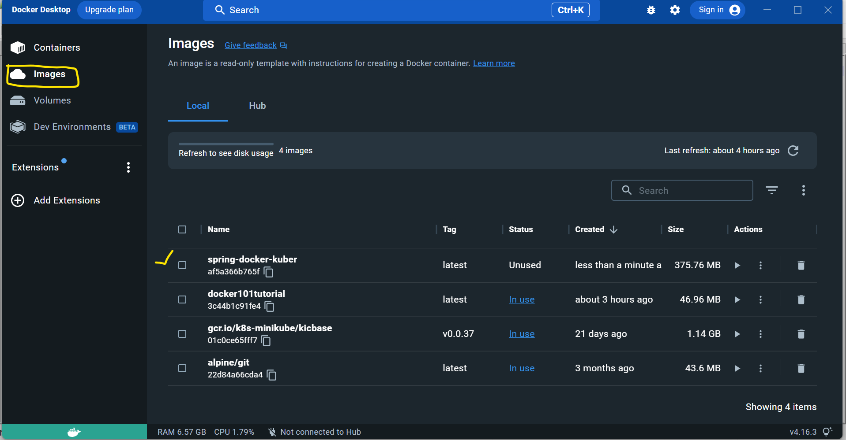

1. **Deploy on minikube**
   1. **Load the image into minikube using the below command:**

**minikube image load spring-docker-kuber:latest**

